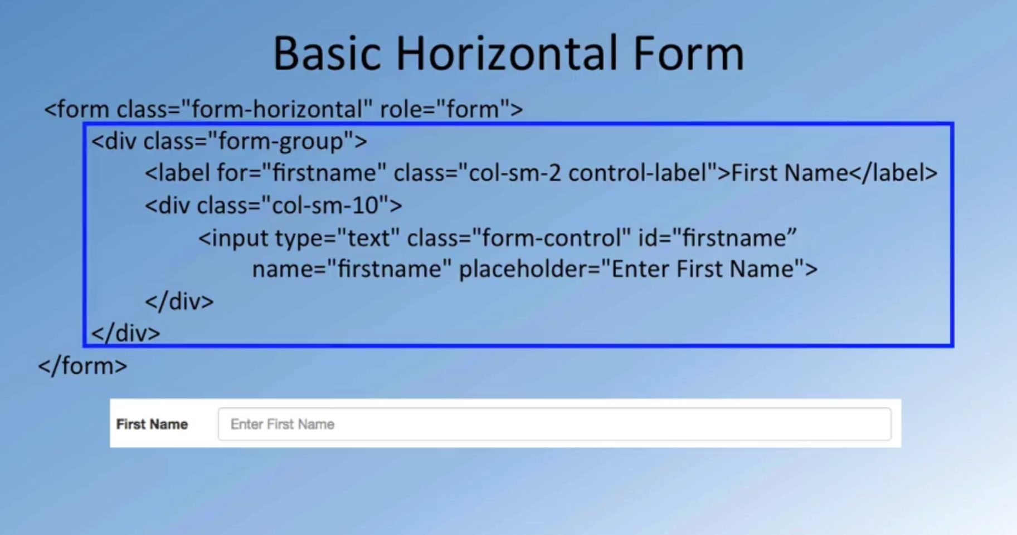

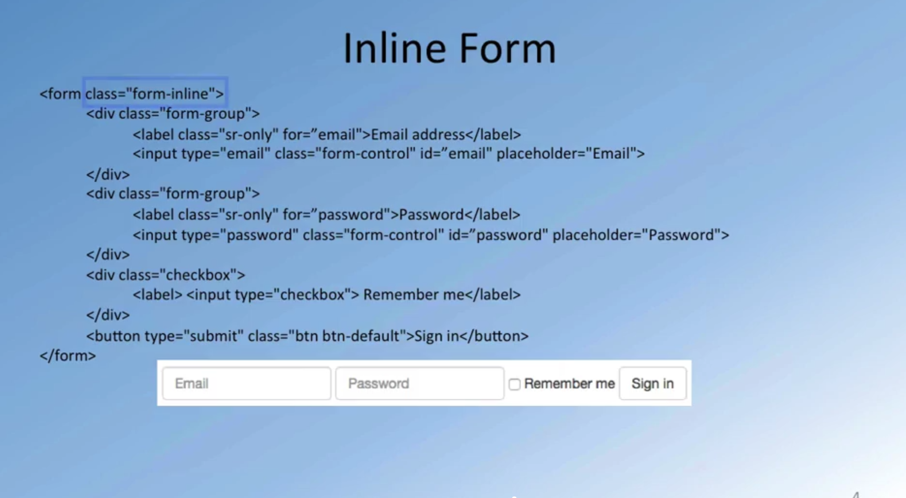

Sr-only – only from screen only

Placeholder = “email”

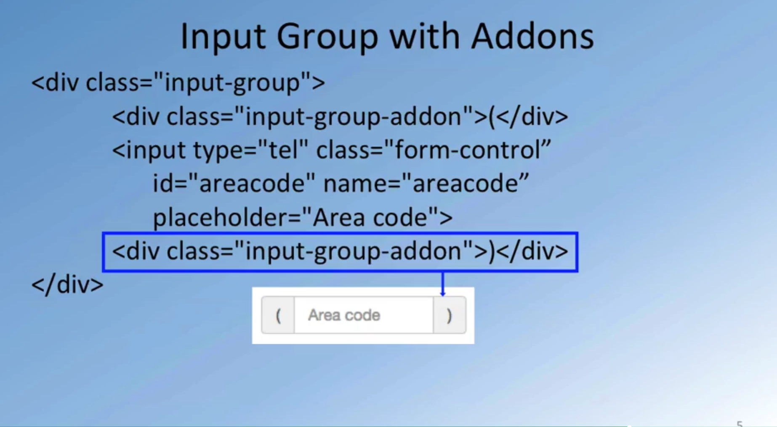

<div class="btn-group" role="group" aria-label="...">

<a type="button" class="btn btn-primary" href="tel:+85212345678"><i class="fa fa-phone"></i> Call</a>

<a type="button" class="btn btn-info"><i class="fa fa-skype"></i> Skype</a>

<a type="button" class="btn btn-success" href="mailto:confusion@food.net"><i class="fa fa-envelope-o"></i> Email</a>

</div>



<div class="form-group">

<label for="telnum" class="col-xs-12 col-sm-2 control-label">Contact Tel.</label>

<div class="col-xs-5 col-sm-4 col-md-3">

<div class="input-group">

<div class="input-group-addon">(</div>

<input type="tel" class="form-control" id="areacode" name="areacode" placeholder="Area code">

<div class="input-group-addon">)</div>

</div>

</div>

<div class="col-xs-7 col-sm-6 col-md-7">

<input type="tel" class="form-control" id="telnum" name="telnum" placeholder="Tel. number">

</div>

</div>

<div class="form-group">

<label for="emailid" class="col-sm-2 control-label">Email</label>

<div class="col-sm-10">

<input type="email" class="form-control" id="emailid" name="emailid" placeholder="Email">

</div>

</div>

**Adding with addons**